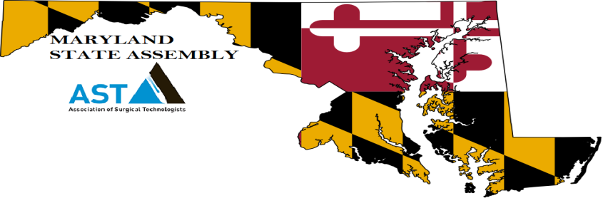
AST MDSA Spring Elections and Workshop Agenda Saturday March 23rd, 2019, BCCC –(Baltimore City Community College)- Fine Arts Center/ Mini Conference Room2901 Liberty Heights Ave., Baltimore Md. 21213
7:00 – 7:45 Opening/ Registration
7:45 8:00 Welcome – Opening Remarks- Meets the Board of Directors for MDSA
8:00 8:50 Kristy Wheeler BSN/ RN/ CNOR/ CST –“Social Media and the OR Professional”
8:50 9:40 Anjel Jaxsen CST/ BS - Clinical Instructor/ Lab Instructor/ Montgomery College – “The Future CST: Bridging the Gap Between The Surgical Technology Student and the OR”
9:45 - 10:15 Business Meeting 1 - Meet the Candidates/ MD DE Merge
10:15 - 11:05 Allyson Murphy, MD Board Certified Pediatric Anesthesiologist – “There’s no I in Team”: Understanding the Vital Components of Intraoperative Anesthetic Care and Understanding How You Can Contribute to Maximizing Patient Safety in the OR.”
11:10 – Noon Dianah Lake, MD/ ER Physician and Wellness and Fitness Expert - “A Patient Care Professionals Guide to Fitness and Weight Management”
12pm - 12:50 Voting / Lunch / Networking - (Exhibit- National Conference Info- May 2019)
12:50 – 1:40 Gene Burke CST/ SALC REP AST - “Making the Best of Your AST Membership”
1:45 – 2:30 Robin McMahon CST –AST Board Member-“AST National Conference Brainstorming Session MDDESA AST”
2:30- 3:00 Business Meeting Part 2- Voting Results and Meet the Board/ Nationals Committee
3:00 – 3:50 Tracey James CST/ MBA – “MAKO Robotic Orthopedic Surgery”
3:55 to 4:10 Closing / Group Pics/ Certificates / Post Workshop Wrap Up

